Q1 a.
Binary Independence Model (BIM) here binary is equivalent to Boolean:documents and queries are both represented as binary term incidence vectors. That is, a document d is represented by the vector x = (x1,....,xm) where xt = 1 if term t is present in document d and xt = 0 if t is not present in d. With this representation, many possible documents have the same vector representation. Many documents can have the same vector representation with this simplification. Independence signifies that terms in the document are considered independently from each other and no association between terms is modeled. This assumption is very limiting, but it has been shown that it gives good enough results for many situations. This independence is the "naive" assumption of a Naive Bayes classifier, where properties that imply each other are nonetheless treated as independent for the sake of simplicity.
The scoring function for BIM -
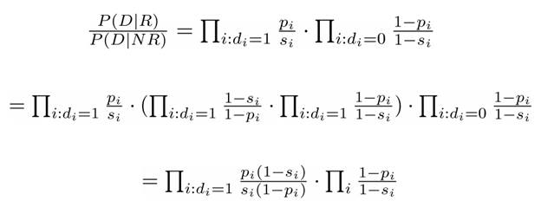
Here, for R=0 or R=1 we can have 2 cases of Probability one if relevant document is retrieved and second if nonrelevant document is retrieved.
Q1 b.

From this graph even when we are varying the values of the parameters, the value remains constant.
We are varying the term weighting component vs the frequency on the x- axis.

Q2. Implementation Details for the Program-
I have implemented using Java programming language. I have created 2 files named IRAssignment4.java and ParseQueries.java
IRAssignment4.java details-
I read the corpus file into a custom created datastructure, it contained a HashMap having key as the word and value as another HashMap which contained key as docid and value as the count for the number of times the word occurred inside that document. I am writing the contents to a file ( index.txt )as
#word
documentid number of times the word occurs.

Another hashmap is created which stores the documentid as the key and the value as the number of tokens inside the document. I am serializing this object to a file.
ParseQueries.java details -
In this program I am reading the index file and the queries file and the number of rows to be displayed. I am reading back the index file into a similar datastructure as created in IRAssignment4. I am taking each query,splitting them by space to get the individual words. For each word I am calculating the total number of times the word occurs in the corpus. And for each of this documentid, I am calculating the BM25 score. BM25 is a ranking function. We keep iterating for all words in the query, and calculate the total score for the query, for each document that word occurs in.
We then output the top 100 documents sorted in descending order of BM25 score.

